

|  |  |
| --- | --- |
| GRADUATE CONNECT  BUSINESS ANALYSIS AND INNOVATION | prepared by:  Team 8:  Lina lukusa  ayaaz mayet  aidan katzef  sipho simelane    INF4027W |

Contents

**BUSINESS ANALYSIS** 3

**INTRODUCTION** 3

**EXISTING BUSINESS PROCESSES** 3

**1.** **Planning of Human Resource:** 3

**2.** **Recruitment:** 3

3. **BBD’s Vacancy Advertisement Process** 4

**4.** **Evaluation and Selection:** 4

**5.** **Offer of the job** 5

**6.** **Induction** 5

7. **BBD Way’s of recruitment activity diagram** 6

**RE-ENGINEERED BUSINESS PROCESSES** 7

**GRADUATE REGISTRATION/LOG IN** 7

**GRADUATES UPLOAD PERSONAL/ACADEMIC MATERIAL** 8

**COMPLETE CULTURE FIT ASSESSMENT TEST** 11

**GRADUATES VIEW RANK (DASHBOARD)** 13

**COMPANY CULTURAL ASSESSMENT** 14

**ADMIN VIEWING AND USING GRADUATES DASHBOARD** 15

**VIEW, MANAGE AND MANIPULATE GRADUATE DATA** 16

Process: 16

**EXISTING BUSINESS RULES** 17

**1.** **GOALS** 17

**2.** **GUIDELINES AND PRINCIPLES** 17

• **Selection of candidates** 17

• **Recruitment** 17

**3.** **AIM AND POLICY.** 17

• **Implementation policy and approach.** 17

**4.** **POLICY’S PROVISIONS** 17

**5.** **The pre-screening of recruitment** 18

**NEW BUSINESS RULES** 18

**1.** **GOALS** 18

**2.** **GUIDELINES AND PRINCIPLES** 19

**3.** **PLATFORM** 19

**4.** **AIM AND POLICY.** 19

• **Implementation policy** 19

• **Policy’s provisions** 19

**5.** **The pre-screening of recruitment** 20

**6.** **Best Practice** 20

**CHALLENGES TO OVERCOME.** 20

**HR CHALLENGES** 20

**CULTURAL FIT CHALLENGES** 21

**POPIA and GDPR CHALLENGES** 21

**ADOPTION CHALLENGES** 21

**BUSINESS VALUE** 22

**MONETARY VALUE** 22

**EFFICIENCY AND PRODUCTIVITY VALUE** 22

**PERFORMANCE VALUE** 22

**EXTRA INFORMATION** 22

**CULTURAL FIT ASSESSMENT** 22

**GRADUATE ASSESSMENT QUESTIONS** 23

**COMPANY CULTURE ASSESSMENT QUESTIONS** 24

**CLIENT DASHBOARD** 25

**FEEDBACK LOOP** 26

**INNOVATION** 27

**NEW TECHNOLOGIES USED** 27

**ANGULAR** 27

**COMMAND LINE INTERFACE (CLI)** 27

**FIREBASE** 27

**CRYSTAL REPORTS** 28

**NEW WAY OF DOING THINGS** 28

**TECHNICAL CHALLENGES TO OVERCOME** 29

**AGILE VALUES** 30

**TASK BOARD** 31

**CONCLUSION** 32

# **BUSINESS ANALYSIS**

# **INTRODUCTION**

This Business Analysis and Innovation document are going to evaluate the existing operations related to the graduate recruitment system for BBD and evaluate opportunities available for developing new ways of doing things better, for this system.

Graduate Connect is a head hunt system that seeks to improve the way companies recruit graduates for the available graduate’s programs and internships. BBD also wants a way to seek out top achieving graduates who fit into their company’s culture. As a result, this has led to a need to build a system that performs this process. This paper is going to discuss and analyze the current businesses process of BBD with regards to the process that is currently being used when seeking for top achieving graduates that fit their company culture, as well as illustrate how this process will be re-engineered by the introduction of the new head hunt system, Graduate Connect.

To accomplish this task, the study will explore and identify the current business rules and processes, as well as challenges that BBD is currently facing and illustrate how the development team is going to go about implementing these rules within the to-be system to be developed and how businesses challenges that arise from this development are to be overcome. This paper will also look at the business value that the system will add to the organization through the provision of the to-be-designed system. The last section of this paper will cover the technical aspect of the development process which will include among others the technologies to be used, the new way of doing things, an elaboration of the technical challenges to be faced with during the development and deployment of the system as well as provide graphical representation of the technical infrastructure of the to-be-designed system.

# **EXISTING BUSINESS PROCESSES**

The following are different sequences that BBD follow to recruit a candidate:

## **Planning of Human Resource:**

In this step, HR determines whether the BBD needs to hire any specific role. The HR predicts the quality and quantity of the required manpower, and defines how the manpower required can be procured considering internal factors such as budget, policies, promotions, and external factors such as economic policies, etc.

## **Recruitment:**

Once the request for additional employees is approved, the following activities are then performed:

* The evaluation and analysis of the job: The role that needs to be filled is evaluated according to the skills, responsibilities and other necessary requirements. Thus, based on the results collected job specifications and descriptions are created. The vacancy is advertised internally within the company, and outside the company by using agencies and other job board like OfferZen to recruit suitable candidates.

1. **BBD’s Vacancy Advertisement Process**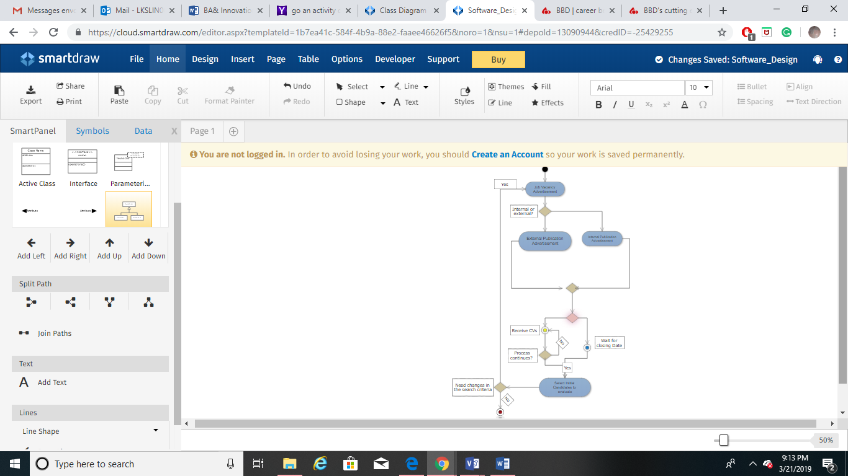

## **Evaluation and Selection:**

The suitable candidates must be evaluated and selected from the pool of applications collected based on:

* Their tests of aptitude
* Personal interviews
* Shortlisting, which is based on the job specification, etc.

After the most appropriate candidates have been evaluated by agencies, their applications are then sent to BBD for a further assessment.

## **Offer of the job**

After the most suitable candidate has been selected, he will get a direct email from BBD which inform that the job has been offered to him/her. Generally, the letter talks about the role and position, the responsibilities, the salary offered and its structure, the joining date, as well as the terms and condition of the letter.

## **Induction**

If the candidate selected to accept the position, he will then be oriented to get him/ her on

board. This aims at making any new employee feel comfortable in the new environment.

1. **BBD Way’s of recruitment activity diagram**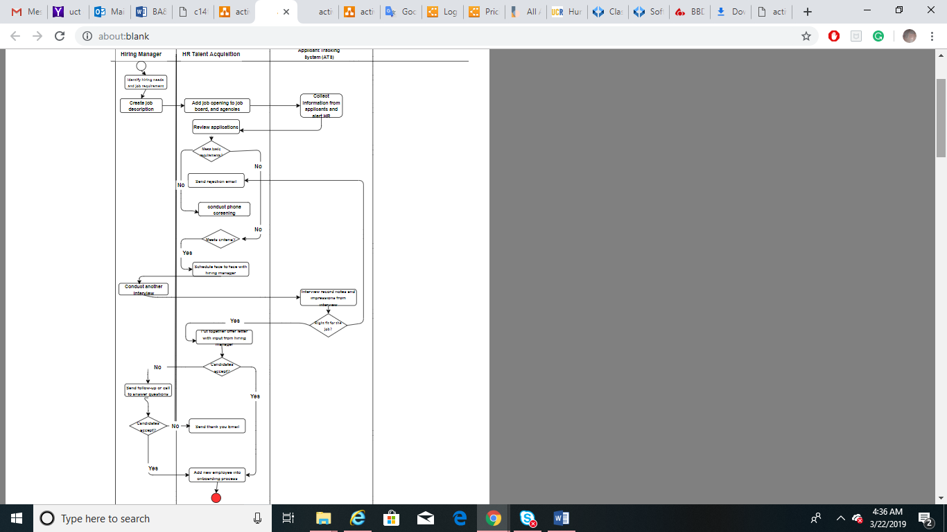

# **RE-ENGINEERED BUSINESS PROCESSES**

The re-engineered business processes described below - aided through the use of activity diagrams - deal with some of the main processes regarding the users - Graduates BBD and admin users - and their respective interactions with the system.

# **GRADUATE REGISTRATION/LOG IN**

Process:

* Graduate accesses the website and is received by the welcome page which indicates the user to log in if they are already registered, or to fill out registration details in order to log in if they are not already registered.
* To register, the graduate must complete the personal information fields followed by verifying their email address via a link sent by a verification email.
* If/once the user is registered they will enter their username and password.
* If the login credentials are incorrect the system will not allow them to log in and they will be directed to reentering their login details (with the option to recover the password using the registered email address if necessary).
* Once the user has logged in they will be taken to their graduates home page.

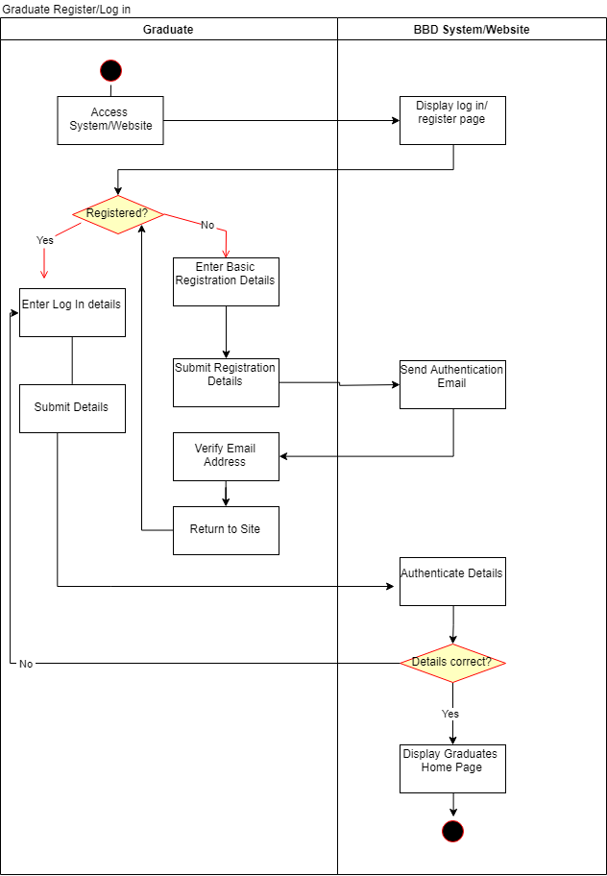Activity Diagram:

# **GRADUATES UPLOAD PERSONAL/ACADEMIC MATERIAL**

Process:

[Note] After the user has registered as per activity diagram above, their ‘Rankable Status’ - which determines whether they have filled out all of the required information to be taken into account for ranking amongst other graduates on the system – is set to ‘Unrankable'. This ‘Rankable Status will depend on particulars such as: completing extra personal information, uploading transcript and academic details, as well as the completion of the culture fit assessment test. Once all of these required have been completed, the graduates ‘Rankable Status’ will be changed to ‘Rankable’. The diagram below deals with the first two requirements namely the completion of extra personal information as well as the provision of academic details.

* Once the student has verified their email accounts a has returned to the website where they would be able to successfully log in, they will have to start perfuming actions which make them closer to being eligible to be ranked.
* They will proceed by selecting the profile tab on the navigation bar which will redirect them to the home page for their profile information.
* They will then be presented with information regarding their personal profiles whereby some data such as the extra personal information, uploading transcript, and academic details, as well as the completion of the culture fit assessment test will be flagged as being incomplete.
* The user will then select and complete the incomplete fields by typing in the answers, selecting them from the presented available options, or uploading certain documents (such as CV’s and transcripts) as required.
* Once the user saves changes made to the profile the system will bind the new data to the profile followed by changing their ‘Rankable Status’ to depict that some tasks have been completed.
* If the user exists without saving changes then the system will show a message confirming that the user has not saved their changes, as well as giving them a chance to, before navigating away from the profile page.

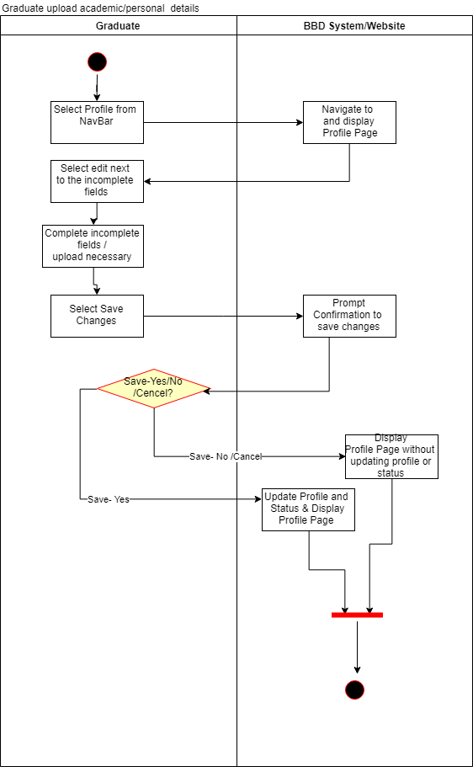Activity Diagram:

# **COMPLETE CULTURE FIT ASSESSMENT TEST**

Process:

[Note] As stated above the graduates ‘Rankable’ Status will depend on particulars such as: completing extra personal information, uploading transcript and academic details, as well as the completion of the culture fit assessment test. This process aims to deal with the completion of the culture-fit-assessment-test which serves as a relay how suitable candidate is to that of the organizational culture of the company.

* The graduate will proceed by selecting the profile tab on the navigation bar which will redirect them to the home page for their profile information.
* The culture fit assessment test will be flagged for incomplete (if the test has not been done before).
* The graduate will proceed by selecting to start the test which they will be directed to afterward.
* The graduate will then have to complete and submit the answers of the test by selecting options ranging from whether they *strongly disagree* to *strongly agree-* with the question/statement in question (having the option to save their answers and come back to them if they do not complete the entire test in one sitting)
* Once the student submits the test upon completion, the system will calculate the test and amend the results with the graduates profile as well as depict this completion of the culture fit assessment test on their ‘Rankable Status’.
* The system will display the results of the culture fit assessment test as well as give graduates some insights.

Activity Diagram:

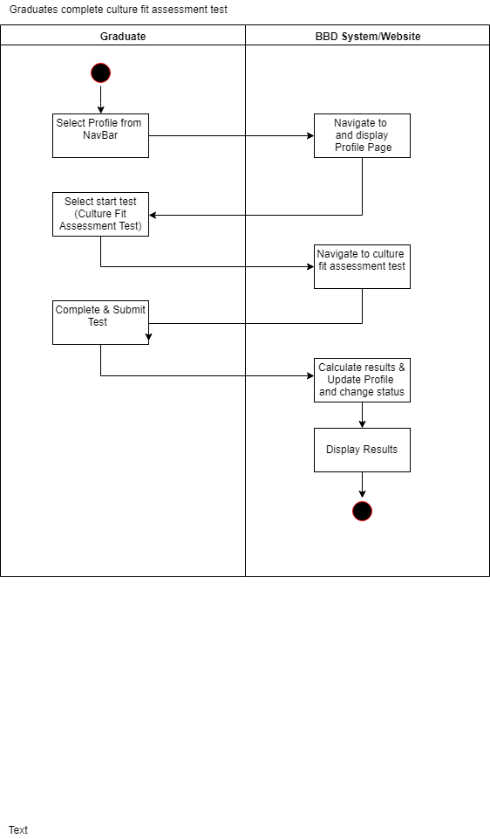

# **GRADUATES VIEW RANK (DASHBOARD)**

Process:

[Note] The graduate's individual dashboard tab will only become available once they have completed all of the necessary requirements making them eligible to be ranked, ie. completing the extra personal information, uploading transcript and academic details, as well as the completion of the culture fit assessment test. Once these have been completed the graduate’s status will be changed to ‘Rankable’ which will allow them to gauge their position amongst other graduates on the platform via information on the dashboard.

* The graduate will select the dashboard ta after logging in which will take them to their individual dashboard which will present information such as ranking and positioning amongst other graduates on the platform according to criteria such as average overall scores, academic results, as well as results from the culture fit assessment test.

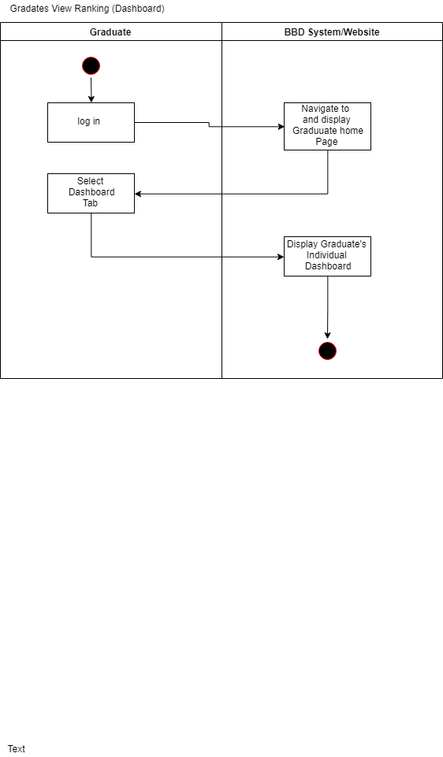Activity Diagram:

# **COMPANY CULTURAL ASSESSMENT**

Process:

[Note] In order for companies like BBD to be able to retrieve/ be presented with candidates which match their desires in terms of fitting into the company culture, they will have to complete a culture assessment test which aims to identify the culture of the company in order to be used against the answers provided by graduates in the culture fit assessment test in order to find suitable candidates according to explicit data. Therefore, once the admin user functionality has been set up, BBD needs to first complete their culture assessment test so that the system has an idea of BBD's company culture.

* The admin user can navigate to the culture tab using the navbar which will navigate them to the page where the assessment will be completed.
* The user will then proceed to complete and submit the answers of the assessment by selecting options ranging from whether they *strongly disagree* to *strongly agree-* with the question/statement in question(having the option to save their answers and come back to them if they do not complete the entire test in one sitting)
* Once the user submits the assessment upon completion, the system will calculate the test results and amend the results with the company’s profile- as well as depict this completion of the culture fit assessment test on their profiles.
* The system will display the results of the culture assessment test as well as give the company some insights.

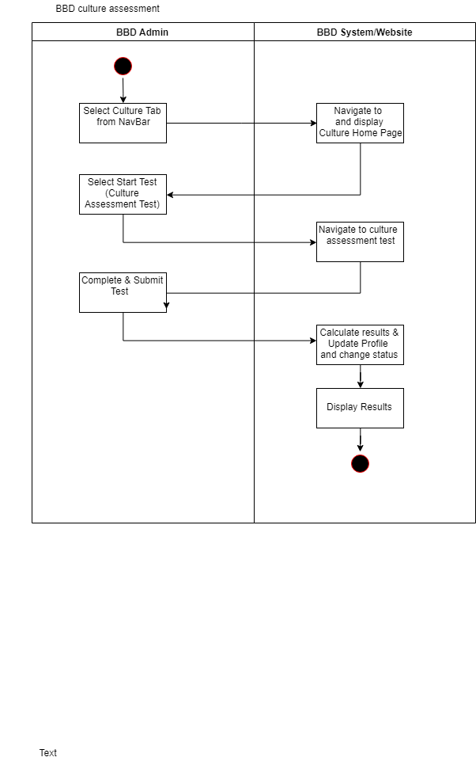Activity Diagram:

# **ADMIN VIEWING AND USING GRADUATES DASHBOARD**

Process:

Once BBD has completed their assessment test and ‘Rankable' graduates have been entered into the system, BBD will be able to get some insights into the graduates' details by being presented with comparative information regarding the ‘Rankable' graduates as well as BBD's assessment test. The data presented will be able to be manipulated as desired through the aids of filters, sorting and reporting functionalities.

* The admin user will select the ‘Graduates Dashboard' tab from the navigation bar which will navigate them to the consolidated graduate's dashboard presenting all information about graduates in a meaningful way in order to try and provide some insights to BBD.
* The system will then generate reports / execute dashboard manipulation instructions as required which will change /manipulate the data presented.

Activity Diagram:

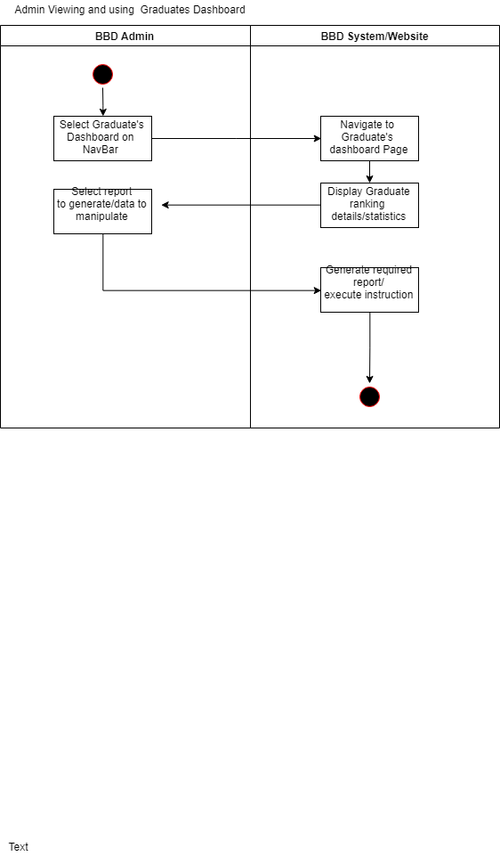

# **VIEW, MANAGE AND MANIPULATE GRADUATE DATA**

# Process:

[Note] Admin users will be able to view all data of graduates in the system in a manipulative tabulated format which will allow them to retrieve full information regarding all data pertaining to individual graduates.

* A logged In admin user can navigate to the ‘All Graduate’s’ page by selecting it from the navigation bar.
* The system will display the details regarding every graduate on the system in a tabulated format in a collapsed view (with the option to view full individual details after expanding on individual graduates by selecting them).
* Graduates personal details such as their contact details will be presented in this expanded view explained in the last point.
* The user may choose to manipulate/manage the presented data by instructing the system to:
* Apply filters
* Sort the data according to column headings
* Search for specific record via some search criteria
* Generate reports

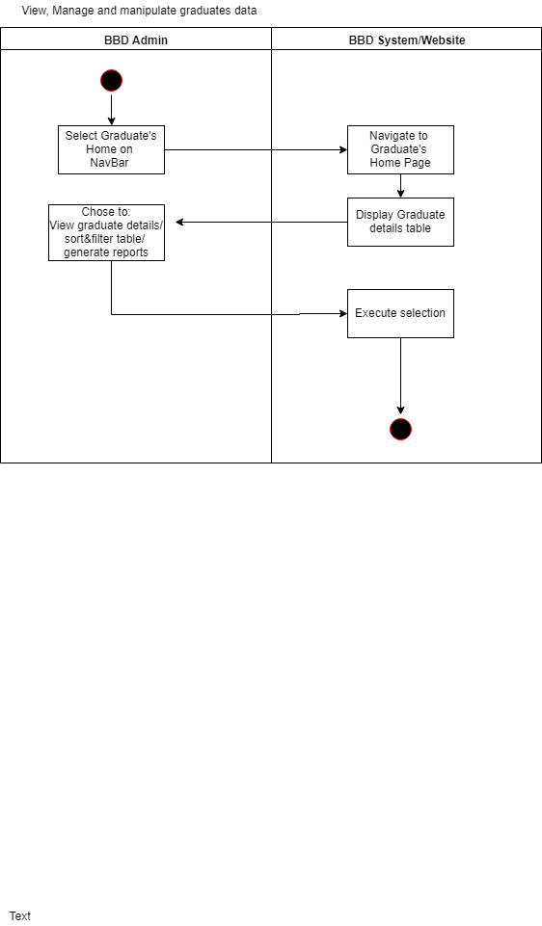Activity Diagrams:

# **EXISTING BUSINESS RULES**

## **GOALS**

The goals of the selection and recruitment policy are as follow:

* BBD aims to find potential candidates to fill the vacancies who will meet the present and future company’s needs.
* The HR department at BBD should ensure that the selection is compliant with the BBD policies as well as the local policies and legislation.
* BBD aims to hire individuals who will embrace the company’s values and fit the vision.
* BBD aims to hire a representative workforce of the South African Economically Active Population (EAP)
* The implementation of Graduate Connect will increase BBD’s employee retention by 20% by October 2020.
* Unsuccessful interview (where the applicant doesn’t get the job) will decrease by 40% by March 2020.

## **GUIDELINES AND PRINCIPLES**

The selection and recruitment’s process need to comply with the context of the laws in which BBD operates, especially the immigration and local labor laws.

### **Selection of candidates**

During the selection of candidates, only short list who meet the organization’s preliminaries requirements will be considered for review. The manager is responsible for the preparation of a structured interview questionnaire which will help the judicial panel to assess the suitability of each candidate for the role.

### **Recruitment**

The recruitment at BBD for vacancies needs to be undertaken internally first. The HR needs to initially consider the available pool with contracts about to expire. And then BBD needs to look to external recruitment methods such as recommendations, agencies, etc.

## **AIM AND POLICY.**

### **Implementation policy and approach.**

The HR is responsible for the communication of any change regarding the policy to the company. The HR department should periodically and systematically review the selection and recruitment policy.

The policy regarding the selection and recruitment provides guidelines that help the BBD to choose suitable graduates with the required competencies that will satisfy the company’s needs.

## **POLICY’S PROVISIONS**

BBD is committed to recruiting graduates who meet the following principles:

* A qualification in IT or related degree
* Graduates with work experience or freshly graduates without any experience
* Candidates who are willing to learn
* Ability to perform the job within a reasonable time.

Regarding the BBD’s guidelines of business conduct, the HR should not directly or indirectly unfairly discriminate candidates on any basis like gender, race, sex, marital status, social and ethic origin, sexual orientation, language, disability, age, religion, political opinion, language, culture, and more.

Currently, BBD has a diverse method of recruitment, which comprises internal recruitment methods (through transfer or promotion of existing employees), external placement methods (Agencies, carrier days, etc.) and employee or chief executive referrals.

It is the responsibility of HR to place external advertisements. These advertisements must comply with the requirements of corporate regarding the usage of BBD's logo, the wording of the advertisement, and the advertisement must maintain the profile and image of BBD.

## **The pre-screening of recruitment**

The goal of pre-screening is to provide priority to the applications of graduates which on first sight are the best-fit candidates. When selecting graduates’ applications, regard is given to:

* The qualifications of the candidates should meet the required role profile.
* The job application form must be completely and correctly filled.
* Internal candidates with the essential development and training suit the vacancy that needs to be filled.

The HR department in consultation with the executive officer then compiles a list of potential candidates. These candidates are then asked to undergo psychometric tests. Before the first interview.

# **NEW BUSINESS RULES**

## **GOALS**

BBD new goals are as follow:

* BBD aims to have its unique fully-functioning, the user-friendly platform of recruitment that matches job opportunities with personality types.
* The platform must assess graduates cultural fit.
* BBD aims to hire top achieving graduates who fit into the company’s culture.
* BBD wants the platform to systematically rank the graduates based on their percentage results and critically asses their cultural fit.
* The platform should be exclusively for ICT graduates and need to provide report functionality.
* The platform must comply with BBD policies and procedures
* The platform must comply with the Protection of Personal Information Act (POPIA) and the General Data Protection Regulation (GDPR) as well as other local and legislative policies.
* BBD aims to recruit a representative workforce of the South African economically active population (EAP)

## **GUIDELINES AND PRINCIPLES**

The selection and recruitment’s process need to comply the context of the laws in which BBD operates, especially the POPIA and GDPR because of the protection of personal data as well as other local and legislation principles.

## **PLATFORM**

BBD ‘s recruitment website must have the following:

* A registration or login section for candidates
* The candidate should fill his/her results in the appropriate section. The website should calculate systematically the average of the results.
* The candidate should be ranked.
* The website should provide a report analysis to the admin that states a list of potential candidates that will fulfill the eligibility principles for a vacant space.
* The platform should be strictly for ICT Graduates.
* The platform should assess the cultural fit of the candidates
* A section for BBD’s admin
* BBD wants to be an employer of choice.
* The platform must include a psychometric test.

## **AIM AND POLICY.**

### **Implementation policy**

HR should periodically review the recruitment policy and update the system regarding any changes in the policy of the company.

### **Policy’s provisions**

The new policies of BBD will be committed to recruiting graduates who meet the following principles:

* A qualification in IT or related degree
* Top-achieving graduates
* Fit the culture of BBD
* Experience or freshly graduates without any experience
* Willing to learn
* Personalities types must match with the job opportunities.

The recruitment platform should not directly or indirectly discriminate any candidates based on gender, race, sex, marital status, social and ethnic origin, sexual orientation, language, disability, age, religion, political opinion, language, culture, and more.

## **The pre-screening of recruitment**

The goal of pre-screening is to provide priority to the applications of graduates which on first sight are the best-fit candidates. When selecting graduates’ applications, regard is given to:

* The candidates must be ICT graduates
* The application form, the results, and the psychometric test must be completely filled.
* The candidates must be a top achiever
* The candidates should fit BBD’s culture.

## **Best Practice**

Determine the minimum job requirements and eliminate any applicants who do not fit the requirements by undertaking a cultural fit test

# **CHALLENGES TO OVERCOME.**

## **HR CHALLENGES**

* The fear of uncertainties of Human Resource Management. This is a natural human aspect to resist to change since employees are familiar with the way they are recruiting for years.

The company should overcome employee’s resistance to change by explaining to employees why the change is required. The company should effectively engage with all employees, employees should be kept in the loop and the organization must ensure that all employees are happy about the change. The company should effectively and efficiently communicate change within the HR department by formal or informal communication to make sure that every employee gets the news.

* The change in the requirement of skill set: Since the business process is being re-engineered, it calls for changes in the requirements of skill set. Employees should be trained to gain intensive skills and knowledge to use the system.
* The change in the structure of the company: Since the new system will replace many manual works it will require a redesign of the company’s structure. Also, the roles and authority relationship of some employees may change. This can lead to an issue of job security in the mind of some employees. Since restricting will abolish certain jobs, the company needs to prepare new responsibilities and roles.

The reengineering of the recruitment necessities an open and supportive organizational culture wherein all the employees should participate in the brainstorming process and provide any suggestions to review and improved the system periodically. All employees in the HR department must feel responsible, free and accountable to provide ideas. This can be achieved through visionary leadership.

Communication is crucial during the reengineering and must be done in every direction (vertically and horizontally).

## **CULTURAL FIT CHALLENGES**

If the cultural fit is not well defined and articulated by the organization then the challenge can arise.

To overcome this challenge, the company should conduct an in-depth study about its culture comprising the company’s goals, values, and practices. The company needs to assess observable artifacts like ceremonies, the meeting behavior, how employees dress, etc. Furthermore, it can evaluate the values that existing employees exhibited on a daily basis.

## **POPIA and GDPR CHALLENGES**

GDPR asks companies to be responsible when they are collecting personal data. This means organizations must know exactly why they are collecting the data, how they are storing the data and how they process it. Also, companies must ensure that they can keep at every stage the personal data secure.

This challenge can make graduates resilient in submitting their data on the recruitment platform.

The candidates should consent to provide his/her data. This will be submitted and saved only if the candidate selects the button that states that he or she agrees and understands to terms and conditions.

Since POPIA and GDPR are asking companies to be accountable for personal data collected and to ensure that they securely stored, then the recruitment platform must prove to do the right thing. This will increase the trust of the candidates; candidates will not feel reluctant to submit their data over. It will also enhance transparency since the platform informs the candidates why they are collecting the data and what they are using it for. As long as the platform collects data for vacancies and candidates are looking to be hired, they will be more engaged candidates who will provide their data over. However, it is not about the size of the candidate willing to provide their data, but how engaged they are with the recruitment platform.

## **ADOPTION CHALLENGES**

The system needs to be user-friendly and intuitive to ensure that both the businesses and graduates make use of the system. Without customer adoption of the system, it will not be successful. The system will be designed to successfully bridge graduates to employees, and this will motivate graduates to use the site.

# **BUSINESS VALUE**

The Graduate Connect system will create value in three forms for the business, namely: monetary value, efficiency and production value, and performance value.

## **MONETARY VALUE**

## 

* New revenue source through BBD charging recruitment commissions for other companies who recruit graduates through the site.
* New revenue source through sales of reports generated from the data provided by the students to marketing companies
* New revenue source through sales of reports generated from the data provided by the students to statistical companies
* Increased revenue indirectly through satisfied customers, increasing customer loyalty and reputation of BBD.

## **EFFICIENCY AND PRODUCTIVITY VALUE**

* Streamline graduate recruitment process through filtering of applicants based on grades and fit within the company, highlighting best-suited applicants.
* Provide headhunting platform as BBD will be presented with eager candidates which show the potential to be the most suitable candidates for them to hire.
* Increased employee retention rate will lead to fewer resources spent on finding new staff and the admin involved with leaving staff. Employing better-suited staff for a position first time around will lead to fewer staff members needing to quit or be retrenched.

## **PERFORMANCE VALUE**

* Through the hiring of better-suited individuals, projects are completed faster, and solutions are better.
* Increased customer satisfaction
* Increased employee satisfaction as employees are better suited for their environment

# **EXTRA INFORMATION**

## **CULTURAL FIT ASSESSMENT**

The cultural fit of a graduate will be assessed in the form of a survey. The survey will include 40 statements which have been structured for both the graduates and a representative from the company hiring to complete. Graduates and company representatives will select whether they strongly agree, agree, disagree or strongly disagree with the statement. The questions are divided into 5 sections with 8 questions in each. For each section both graduates and company representative can only rank two statements as “strongly agree”, this will allow the system to easily identify any strong cultural matches

The survey statements have been sourced from a site using Marston's cultural fit framework, where 8 types of company cultures were defined, namely: dominant culture, accommodating culture, convincing culture, introverted culture, down-to-earth culture, animated culture, precise culture, and headstrong culture.

The below scoring system will be used to assess a graduate’s cultural fit with the organization:

Graduate Answer

Company Answer

|  |  |  |  |  |
| --- | --- | --- | --- | --- |
|  | Strongly Agree | Agree | Disagree | Strongly Disagree |
| Strongly Agree | 2 | 1 | -0.5 | -1 |
| Agree | 1 | 1.5 | -0.5 | -0.5 |
| Disagree | -0.5 | -0.5 | 1.5 | 1 |
| Strongly Disagree | -1 | -0.5 | 1 | 1.5 |

The final score for each graduate will be a score out of 55 and will be shown as a percentage on the company’s dashboard.

## **GRADUATE ASSESSMENT QUESTIONS**

Set one:

1. **In project groups, I can be quite assertive**

2.**In project groups I prefer to influence people**

3.**In project groups I prefer to join in with others**

4.**I like to follow rules and regulations in my workspace**

5.**In project groups I like to accommodate other people's wishes**

6.**For projects I prefer to work quietly on my own**

7. **I like to move at a fast pace**

8.**For projects I like to work independently**

Set two:

9.**I like to direct other people’s activities**

10.**I like to convince people to carry out activities**

11.**I like to do complete tasks quickly myself for the best results**

12.**I like to create things**

13.**I like a close-knit team in which to work**

14.**I like to be formal and work to standards**

15.**I like to be clearly told what to do**

16.**I like to be left to get on with it**

Set three:

17.**At work people should be persuaded to do things**

18.**At work people should follow carefully laid down procedures**

19.**At work once you know what is required, you should be left to get on with it**

20.**At work there are too many rules and they get in the way of doing the job**

21.**At work, if I am a leader, I expect others to follow what I say**

22.**At work leaders should seek consensus before proceeding**

23.**At work people should accommodate and serve their leader**

24.**At work there is too much to do to wait for instructions. Just get on with it**

Set four:

25.**At work people would best describe me as go-getting**

26.**At work people would best describe me as precise**

27.**At work people would best describe me as thoughtful**

28.**At work people would best describe me as energetic**

29.**At work people would best describe me as obliging**

30.**At work people would best describe me as independent**

31.**At work people would best describe me as assertive**

32.**At work people would best describe me as accurate**

Set five:

33.**I can best be described as competitive and decisive**

34.**I can best be described as poised, persuasive and optimistic**

35.**I can best be described as team-focused, reliable and persistent**

36.**I can best be described as precise, systematic and compliant**

37.**I can best be described as diplomatic and modest**

38.**I can best be described as intuitive, introspective and exploring**

39.**I can best be described as eager, outgoing and mobile**

40.**I can best be described as unconventional, creative and independent**

## **COMPANY CULTURE ASSESSMENT QUESTIONS**

Set one:

1.**Employees should be quite assertive**

2.**Employees should prefer to influence people**

3.**Employees should prefer to join in with others**

4. **Employees should follow rules and regulations in my workspace**

5.**Employees should accommodate other people’s wishes**

6.**Employees should prefer to work quietly on their own**

7. **Employees should like to move at a fast pace**

8.**Employees should like to work independently**

Set two:

9.**Employees will direct other people’s activities**

10. **Employees will convince people to carry out activities**

11. **Employees will complete tasks quickly myself for the best results**

12. **Employees will like to create things**

13. **Employees will like a close-knit team in which to work**

14. **Employees will be formal and work to standards**

15.**Employees will be clearly told what to do**

16.**Employees will be left to get on with it**

Set three:

17.**At work people should be persuaded to do things**

18.**At work people should follow carefully laid down procedures**

19.**At work once you know what is required, you should be left to get on with it**

20.**At work there are too many rules and they get in the way of doing the job**

21.**At work, others should follow what is said by the leader**

22.**At work leaders should seek consensus before proceeding**

23.**At work people should accommodate and serve their leader**

24.**At work there is too much to do to wait for instructions. Just get on with it**

Set four:

25.**Our employees are best described as go-getting**

26. **Our employees are best described as precise**

27. **Our employees are best described as thoughtful**

28. **Our employees are best described as energetic**

29. **Our employees are best described as obliging**

30. **Our employees are best described as independent**

31. **Our employees are best described as assertive**

32. **Our employees are best described as accurate**

Set five

33. **Our employees can best be described as competitive and decisive**

34. **Our employees can best be described as poised, persuasive and optimistic**

35. **Our employees can best be described as team-focused, reliable and persistent**

36. **Our employees can best be described as precise, systematic and compliant**

37. **Our employees can best be described as diplomatic and modest**

38. **Our employees can best be described as intuitive, introspective and exploring**

39. **Our employees can best be described as eager, outgoing and mobile**

40. **Our employees can best be described as unconventional, creative and independent**

## **CLIENT DASHBOARD**

Once the hiring company has completed its company culture assessment and selected the skillsets required for the position, graduated will be displayed on their dashboard in ranking order. This rank will be a weighted average of the graduate's IT academic results, skillset compatibility, and cultural fit percentage. It was identified in our interview with our sponsor that heavy importance was placed on grades in the recruitment process of graduates as grades are a mechanism to determine one's aptitude and ability, for this reason graduates academic results will be weighted more than their skillset alignment and cultural fit with a ratio of 2:1:1. Clients will, however, be able to sort the list of graduates by solely academic scores, skillset or cultural fit.

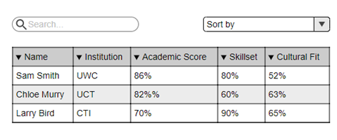

## **FEEDBACK LOOP**

The culture fit assessment, skillset, and academic results are just mechanisms used to try and determine a graduate’s ability and fit within the company and thus will never be full proof, Graduate Connect will, however, implement a feedback loop to continuously improve the process for better results. After set periods of time company’s HR departments will be asked for updates on the graduate’s performance within the company, whether or not they are working well with the team, if they’ve changed departments or if they’ve resigned or been retrenched. This information can then be used to try and find commonalities between successful graduates as well as potential warning signs. This analysis can then be used to adjust the filtering process and increase the accuracy of the system

## **INNOVATION**

## **NEW TECHNOLOGIES USED**

## **ANGULAR**

Angular is a JavaScript framework for building client-side applications that provide a stable programming environment to facilitate the design of a dynamic web application. The aim of using this framework is to produce a dynamic website that is faster and performant while writing less code as possible and the code is cleaner. The language we are going to use to develop this system is the TypeScript programming language.

This framework is going to allow the team to practice code-first and database-first programming approach at the same time, by customizing the entity framework can easily be used to build the web application since it is going to be used together with Firebase, which is a real-time cloud database. This means that the database will be created at the same time as the code is being written. The framework also provides a powerful way of achieving effective things in a way that embraces and extends HTML, CSS, and JavaScript. This is going to be helpful since we want to make the user experience for BBD, students, Admin etc. to be the best.

## **COMMAND LINE INTERFACE (CLI)**

The CLI will be used to interact with the computer program which makes it easy to set up the website, testing and building the system. Testing is a very important aspect of a system, where we test all the use cases and other exceptional use cases, the CLI will make this process easier. This will help to make sure that the hunt system is fast, performant, and is of high quality. The CLI requires less memory, fewer computer resources, in order to use, compared to other interfaces and provide speed at the same time, which will improve the team's productivity.

Microsoft Visual Studio Team Services

As mentioned above, the development of the Graduate Connect head hunt system is going to be achieved using Angular with TypeScript as the programming language. Angular works together with Nodejs to create a cross-platform runtime environment, which is the reason the team is going to use Microsoft Visual Studio Code to incorporate all these frameworks together.

Visual Studio Code is a lightweight but powerful source code editor that will allow the use of TypeScript and Nodejs for developing the head hunt system since it comes with built-in support for JavaScript, TypeScript, and Node.js.

This framework is going to allow ASLA to use the agile tools that are built into the framework since we are using the agile methodology for this project. it also provides continuous integration and the use of private repositories in Git.

## **FIREBASE**

1. Firebase is a real-time NoSQL cloud database, that is going to be used when building the system without the need to build the backend. Firebase is going to manage the relationship between the Angular framework and the cloud database, making sure that data is stored and retrieved successfully. Since the system is going to be storing sensitive data such as students' grades, Angular is going to make it possible for the system to provide privacy for the data because it also provides a messaging service and authentication service.

## **CRYSTAL REPORTS**

One of the important requirements from our product backlog is that BBD must be able to use the website to generate reports. Crystal reports will be used to generate high-quality real-time reports from the system. It is based on SAP technology that connects to virtually any data source. Crystal reports will also offer BBD the opportunity to choose from a variety of reporting formats and allow them to make that content available offline as well. This technology will form part of incorporating business intelligence into the design of the Graduate Connect head hunt system for BBD.

## **NEW WAY OF DOING THINGS**

The Graduate Connect head hunt system will bring change within the organization as the system will improve the way the organization currently deals with recruiting fresh, top achieving graduates straight from varsity. The new website, Graduate Connect, will make it easy for BBD and other companies to select and choose top achieving graduates that fit their company culture. Below we get into more details with regards to the head hunt system (students, BBD, companies etc.) will things to achieve their goals.

***For BBD***

The  new  head  hunt  system,  Graduate  Connect,  will  enable  BBD to  identify the following points:

* BBD is going to be able to identify top achieving graduates straight from varsity and have the preference to choose the ones they want first before any company can choose.
* BBD is going to be able to select those graduates that fit perfectly into their company culture.
* BBD  will  be  able  to  use  the  system  to  rank  students  according  to  their  marks  and  other  tests provided  by  the  system
* BBD will now be able to add to their business value by charging a certain fee amount to other companies that want to use the system.
* BBD will form relationships with other top companies interested in the head hunt system
* Admin will now be able to generate reports in different formats.

***For Students (Graduates)***

* Students will be able to create an account on the website and volunteer upload their marks on the system.
* Students will be able to see their rankings on the dashboard compared to other students from other institutions.
* Students will be offered jobs that fit their skills and personalities.
* Students will be able to take an online test to test their understandings and personality

***For Other Companies***

* They will be able to hire top achieving graduates that fit their company culture.
* Register and create an account on the system.

The Graduate Connect head hunt system will change the recruitment process forever, making it be faster and shorter. The Angular framework will allow us to develop a faster and performant system that is of high quality.

## **TECHNICAL CHALLENGES TO OVERCOME**

After identifying the new technologies used for the head hunt system, doing things, technical challenges that arise as a trying to achieve and functionality.

*From the Team (ASLA) Perspective*

* The team, ASLA Angular framework, we have regards to using this platform for developing a system. This framework also requires the team to use TypeScript as the programming language, which we also have no prior experience using itWe , we currently busy with an introduction to them and also introduces TypeScript. this framework, understand important features. easy, the end, this framework. going to challenge since it to understand a framework.
* method approach code team services. the system to result in high quality.

*From BBD Side*

* The  Administration Department of BBD will have to convert the data from the system into reports using the recommended software, this can be a big challenge if there is a lack of understanding of the software, or the software is being used ineffectively.

*Other Challenges*

* Other organizations may not want to use the Graduate Connect head hunt system, because of the fee charged and all other important reason. But they could still be aware of the value of information stored in the database that is used by this system and may try other means of gaining access to the data, ways that are illegal. in other words, the system needs to overcome the challenge of unauthorized users, hackers etc. to keep the graduate's information secured. The team needs to understand the framework in order to use its features effectively to provide reliable protection for the database.

Technical Infrastructure

**The diagram to help explain the technical architecture for the system**

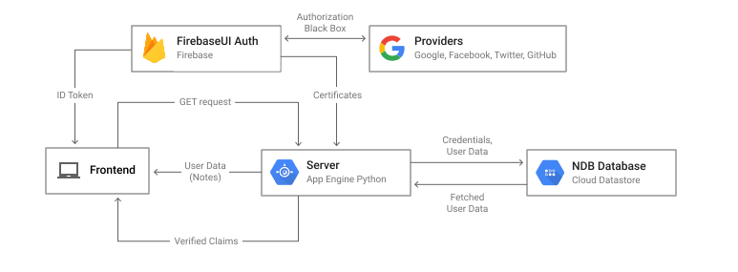*The Architecture diagram related to the Graduate Connect Head Hunt System Technical Infrastructure*

* Since Firebase is a real-time NoSQL cloud database, the Graduate Connect Head Hunt in the cloud, that is maintained and supported by Google service providers and can be the internet. such architecture is able to store user credentials and associated data in Cloud Datastore. This type will help to configure the Firebase Authentication user interface, obtain a Firebase ID token and verify it using server-side authentication.

All queries from Graduate pulled from the database using the NDB client library, which is in turn linked to the Firebase cloud database.

## **AGILE VALUES**

Agile we will teach us to be self-organized and motivated and the way we can deal with change in today's growing digital world.

Agile's principles can be implemented in any type of work.  Since agile is culture, and thus it becomes a mindset. We can apply its principles in every organization we can have the opportunity to work in.

Agile will shape our approach regarding teamwork and effective collaboration.

The principle of agile is to deliver frequently short development increments. This will help us to improve our knowledge and work, instead of overestimating our level of knowledge. The agile project will help us to reflect on how to be more effective and always adjusts accordingly. The reflection will be at the individual level and as a team.

Finally, the project will boost our motivation to deliver great work after seeing that the frequent iterations are appreciated. We will get the hunger to deliver more effective and efficient work.

## **TASK BOARD**

For this project we will be using Trello for its task board functionality as seen in the below screenshot:

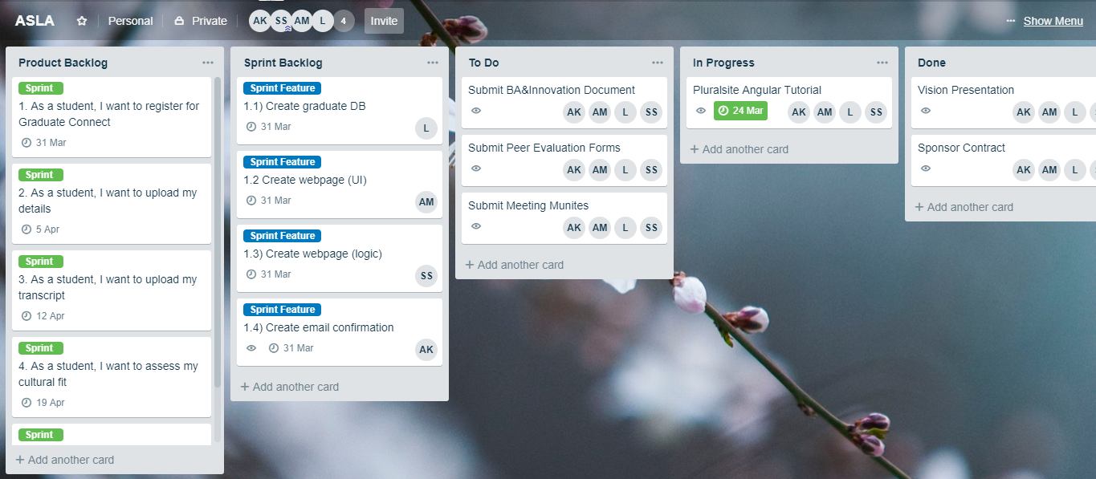

Class Diagram for Graduate Connect System

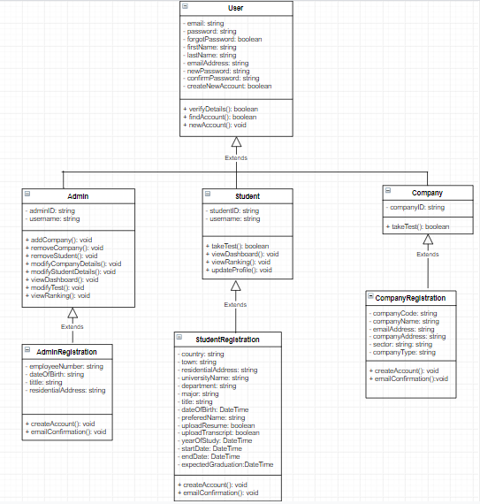

Package Diagram for BBD

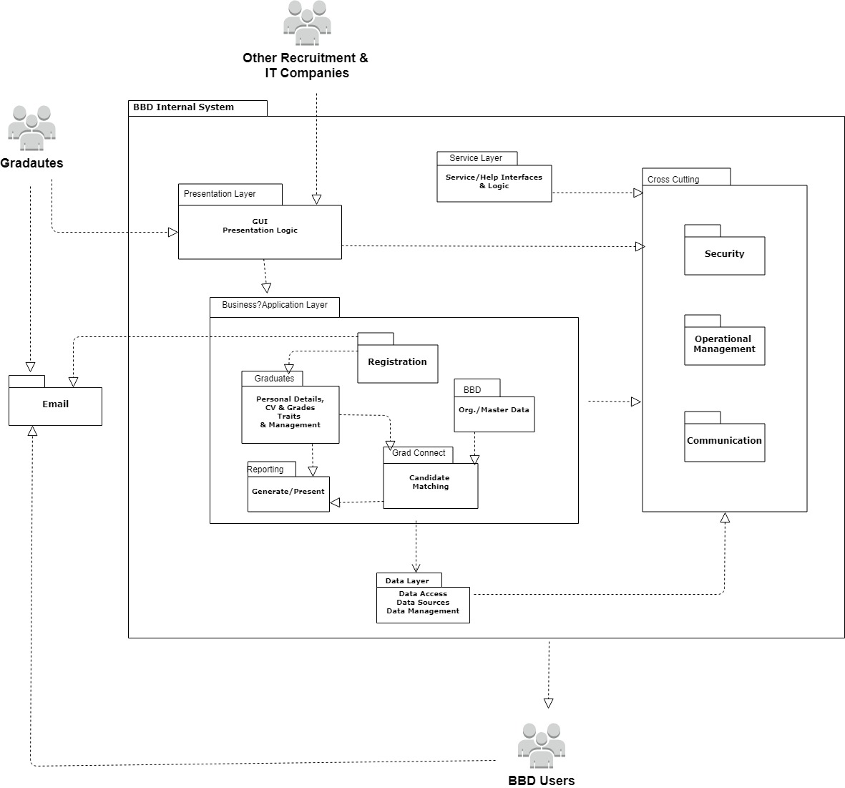

## **CONCLUSION**

This Business Analysis and Innovation document analyzed BBD's current graduate recruiting process through evaluating the existing business rules, processes and challenges. Through this analysis, we identified the need for a new graduate recruiting system (Graduate Connect). This document proposes a new to-be system and how this system will work and affect BBD. The business value made available from this system was detailed as well as technical challenges to overcome and a diagram representing the technical infrastructure of the to-be system.